Test Case: tc002_SPX_Dev5_Crear_Requisicion_Spot_Tipo_Cobro_Project
Step 1 - Enter username and password and click to button Enter: Credentials Entered
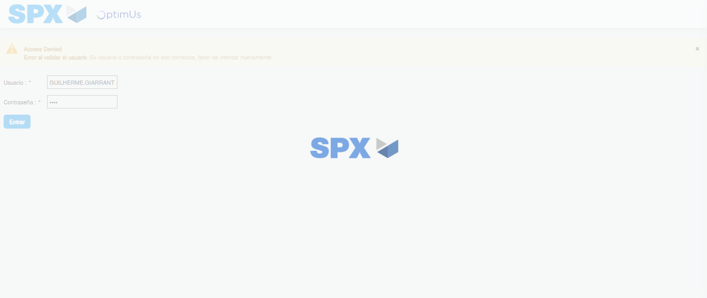Image file-name: QC_Testing-tc002_SPX_Dev5_Crear_Requisicion_Spot_Tipo_Cobro_Project-1784309771020

Step 2 - Select to UEN and Access to Spot Buy Requisitions : UEN Correctly selected and Correct access
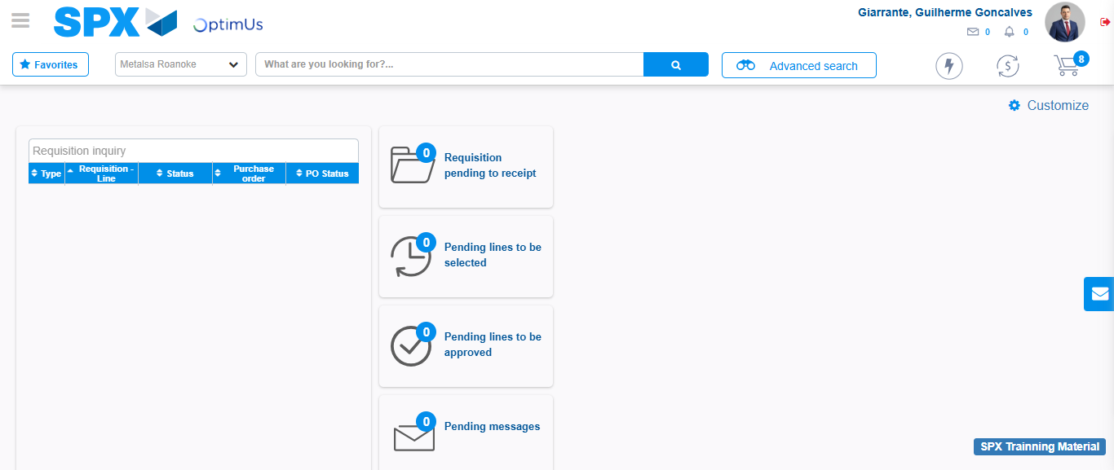Image file-name: QC_Testing-tc002_SPX_Dev5_Crear_Requisicion_Spot_Tipo_Cobro_Project-1784309797484

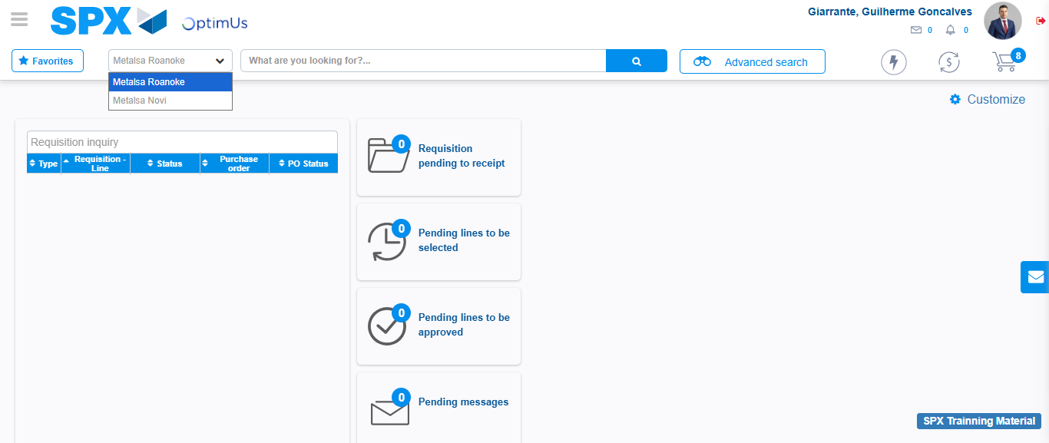Image file-name: QC_Testing-tc002_SPX_Dev5_Crear_Requisicion_Spot_Tipo_Cobro_Project-1784309800128

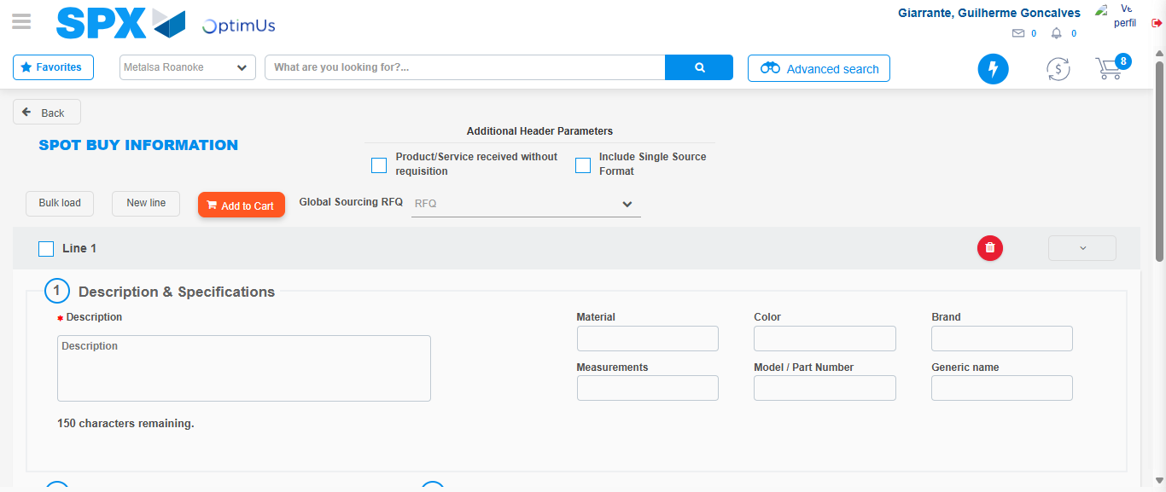Image file-name: QC_Testing-tc002_SPX_Dev5_Crear_Requisicion_Spot_Tipo_Cobro_Project-1784309819866

Step 3 - Data Capture Spot Buy Requisition: Data captured correctly
Image file-name: QC_Testing-tc002_SPX_Dev5_Crear_Requisicion_Spot_Tipo_Cobro_Project-1784309820150

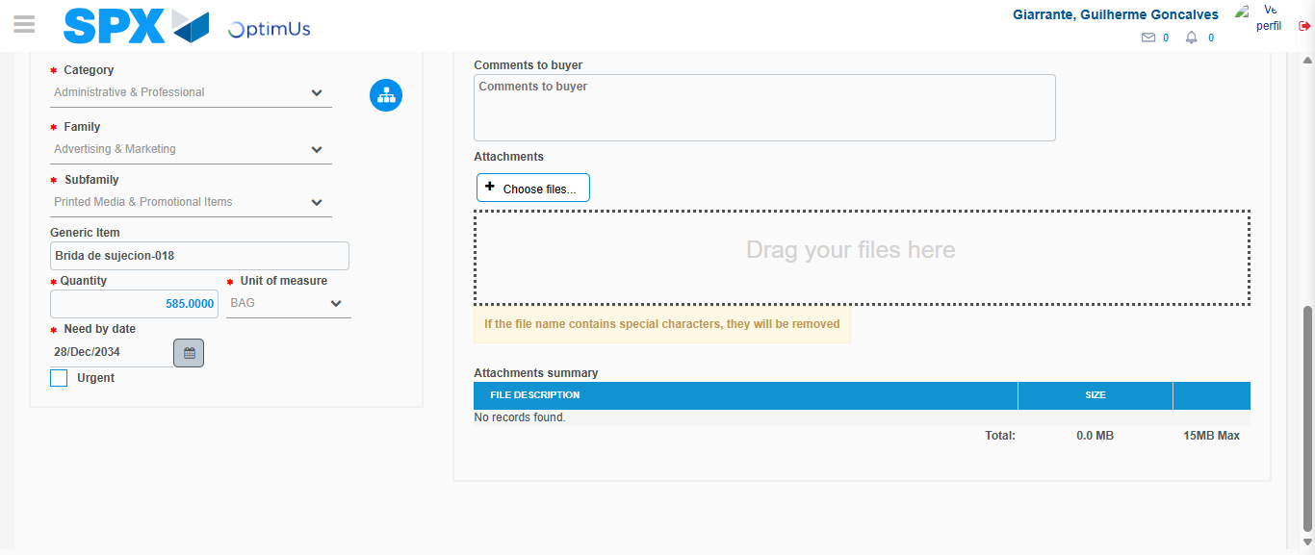Image file-name: QC_Testing-tc002_SPX_Dev5_Crear_Requisicion_Spot_Tipo_Cobro_Project-1784309833501

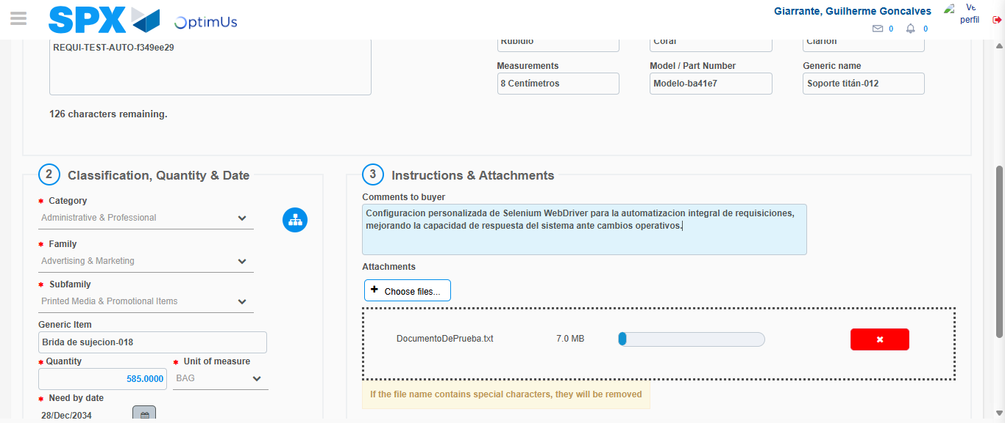Image file-name: QC_Testing-tc002_SPX_Dev5_Crear_Requisicion_Spot_Tipo_Cobro_Project-1784309834508

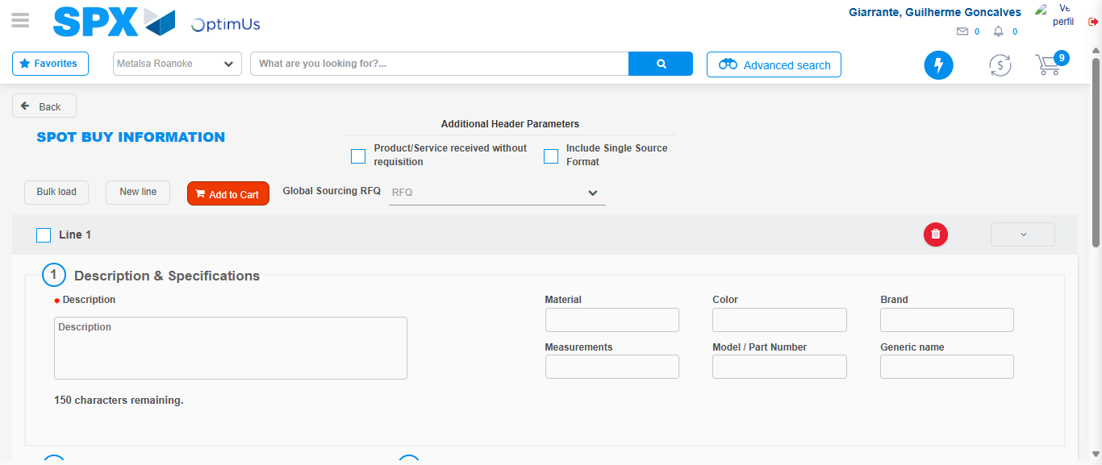Image file-name: QC_Testing-tc002_SPX_Dev5_Crear_Requisicion_Spot_Tipo_Cobro_Project-1784309840475

Step 7 - Return to Main Page SPX : Return to Main Page SPX
Image file-name: QC_Testing-tc002_SPX_Dev5_Crear_Requisicion_Spot_Tipo_Cobro_Project-1784309797484

Image file-name: QC_Testing-tc002_SPX_Dev5_Crear_Requisicion_Spot_Tipo_Cobro_Project-1784309800128

Image file-name: QC_Testing-tc002_SPX_Dev5_Crear_Requisicion_Spot_Tipo_Cobro_Project-1784309819866

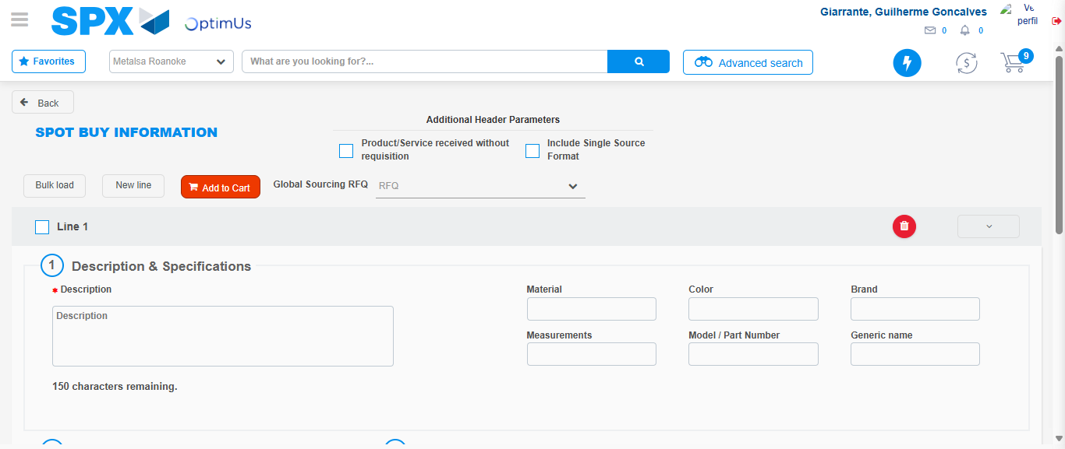Image file-name: QC_Testing-tc002_SPX_Dev5_Crear_Requisicion_Spot_Tipo_Cobro_Project-1784309842759

Image file-name: QC_Testing-tc002_SPX_Dev5_Crear_Requisicion_Spot_Tipo_Cobro_Project-1784309842979

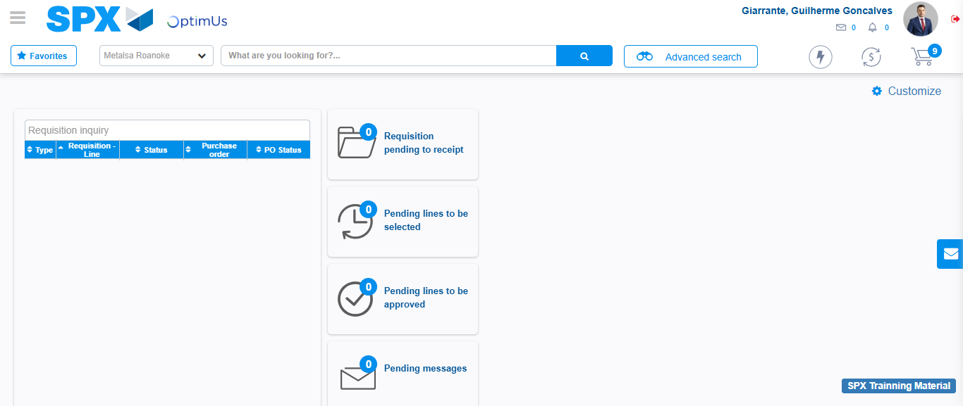Image file-name: QC_Testing-tc002_SPX_Dev5_Crear_Requisicion_Spot_Tipo_Cobro_Project-1784309864272

Step 8 - Log Out : Log Out SPX
Image file-name: QC_Testing-tc002_SPX_Dev5_Crear_Requisicion_Spot_Tipo_Cobro_Project-1784309864465

